R.C.Y.C. Fall Training Programs

The fall is one of the best times of the year to sail in Toronto. The water is still relatively warm and the wind is much better than summer months. It is also a good time to get a leg up on the competition who may not be training. So keep your skills sharp and join in!

Monday Madness: September 10, 17, October 1, 8
Time: 4pm-7pm (until dark)
Cost: $300

Super Saturdays: October 6, 13, 20, 27, and November 3rd
Time: Be rigged for 11am sailing till 3pm (approx)
Cost: $300
Optimist Saturdays: September 15, 22, 29, October 6, 13, 20
Time: Be rigged for 11am sailing till 3pm (approx)
Cost: $300

Regatta Coaching: $100 per event per participant

There is a limited number of charter boats, please contact Dan Cunningham at extension 559 for availability

If you have not sailed in the fall before, we highly advise that you have the following gear for your sessions: Toque, warm gloves, booties, full length wetsuit, or dry suit, and thermal under layers.

* It is the Participant’s responsibility to check the weather and dress appropriately
* Sessions will vary in length depending on weather
* Coaching fees are subsidized; there will be NO REBATES OR PRO-RATED FEES

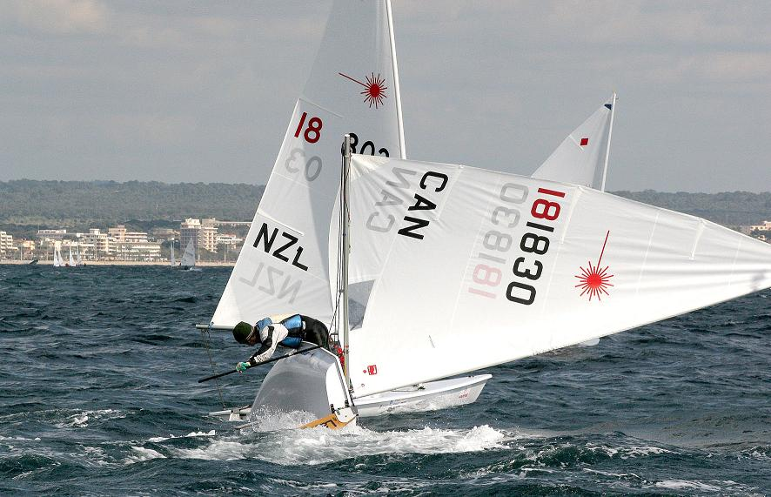

Junior Club Graduates, who join the High Performance Team next spring will be refunded for Fall Training Fees.


The Royal Canadian Yacht Club

Fall Training Program, 2007
Registration Form

Athlete Name: ____________________________________________________________________________________

Date of Birth: Day ___ Month ___ Year ____

Address: __________________________________________________________________________________________________________________________________________________________________________________

Home Telephone: ________________________ Alternate Telephone: _______________________________

Email: ___________________________________________________________________________________

Emergency Contact Person: __________________________________________________________________

Home Telephone: _____________________________ Alternate Telephone:___________________________

Health Card Number: _____________________________________

Please describe your previous sailing/racing experience, and where that experience was obtained:

________________________________________________________________________________________ ________________________________________________________________________________________ ________________________________________________________________________________________ ________________________________________________________________________________________

Participating in which fleet: Laser __ Laser Radial __ Optimist __ 29er__

Program Fees:

Monday Madness $300___ Super Saturdays $300 ___ Opti Saturdays $300 ___

RCYC Account Number: _____________ OR Check enclosed: ___________

Member Accounts will be billed upon receipt of the registration form.

Please make the program check payable to: The Royal Canadian Yacht Club. Program checks should be dated for the day that they are submitted. Checks will be deposited within one week of being received by the Sailing Office. NO rebate or financial reimbursement will be returned.
*I UNDERSTAND THAT A PROGRAMME OF THIS NATURE CONTAINS AN ELEMENT OF HAZARD AND, IN THIS RESPECT, I ACCEPT THE FULL RESPONSIBILITY OF THE PRESENCE OF THIS MEMBER OF MY FAMILY IN THIS PROGRAMME AND RELEASE THE ROYAL CANADIAN YACHT CLUB, ITS COMMITTEES, AND EMPLOYEES OF ANY AND ALL LIABILITY, FOR ANY AND ALL DAMAGES, OR INJURY, HOWEVER CAUSED. I HEREBY ACKNOWLEDGE THAT I HAVE READ AND AFFIRM THE ENTIRE CONTENTS OF THIS APPLICATION

Signature of Athlete or Guardian (if athlete is under 16)* : _________________________________________

.
Forms can be faxed to the rcyc head race coach at (416) 967 5710 or e-mailed to racingcoach@rcyc.ca

