Opti Racing Program offered at KYC

July 2008

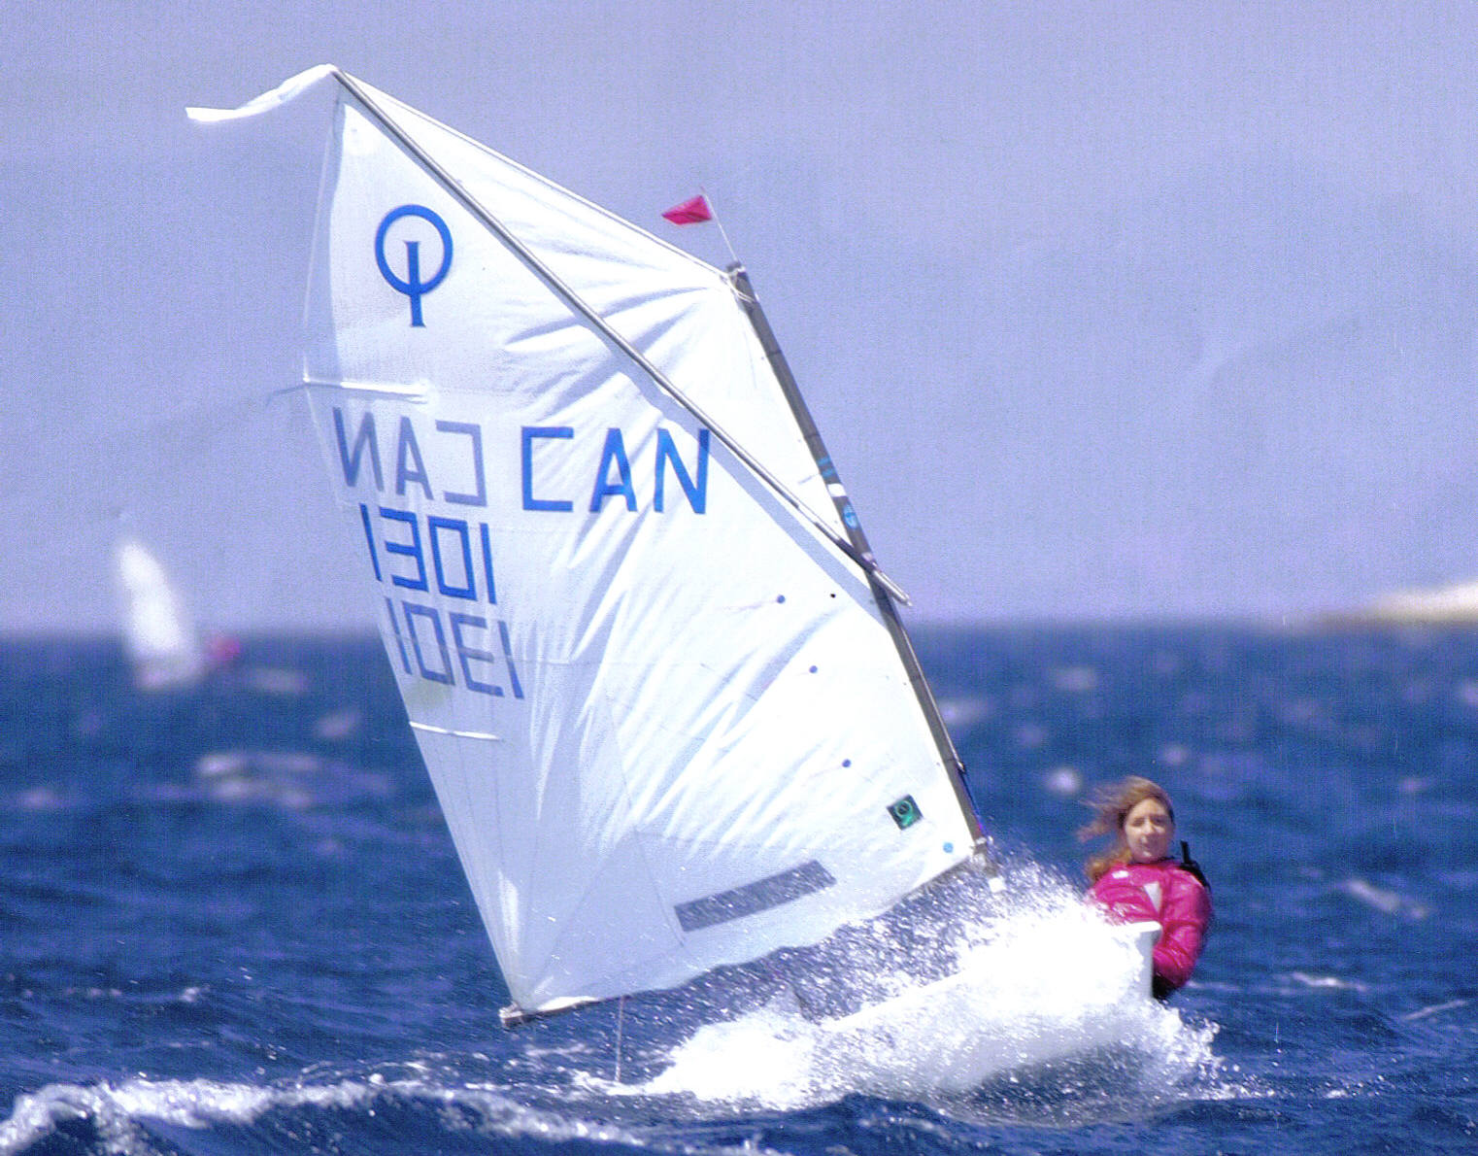
Kingston Yacht Club Junior Sailing is offering an Opti Race Program for the month of July for qualified Opti sailors. There will be a maximum of six sailors, under the instruction of Kim (Case) Foley. This program includes coaching at two weekend regattas such as Fogh Boorman (at RHYC) and the Four Sisters (at PCYC).

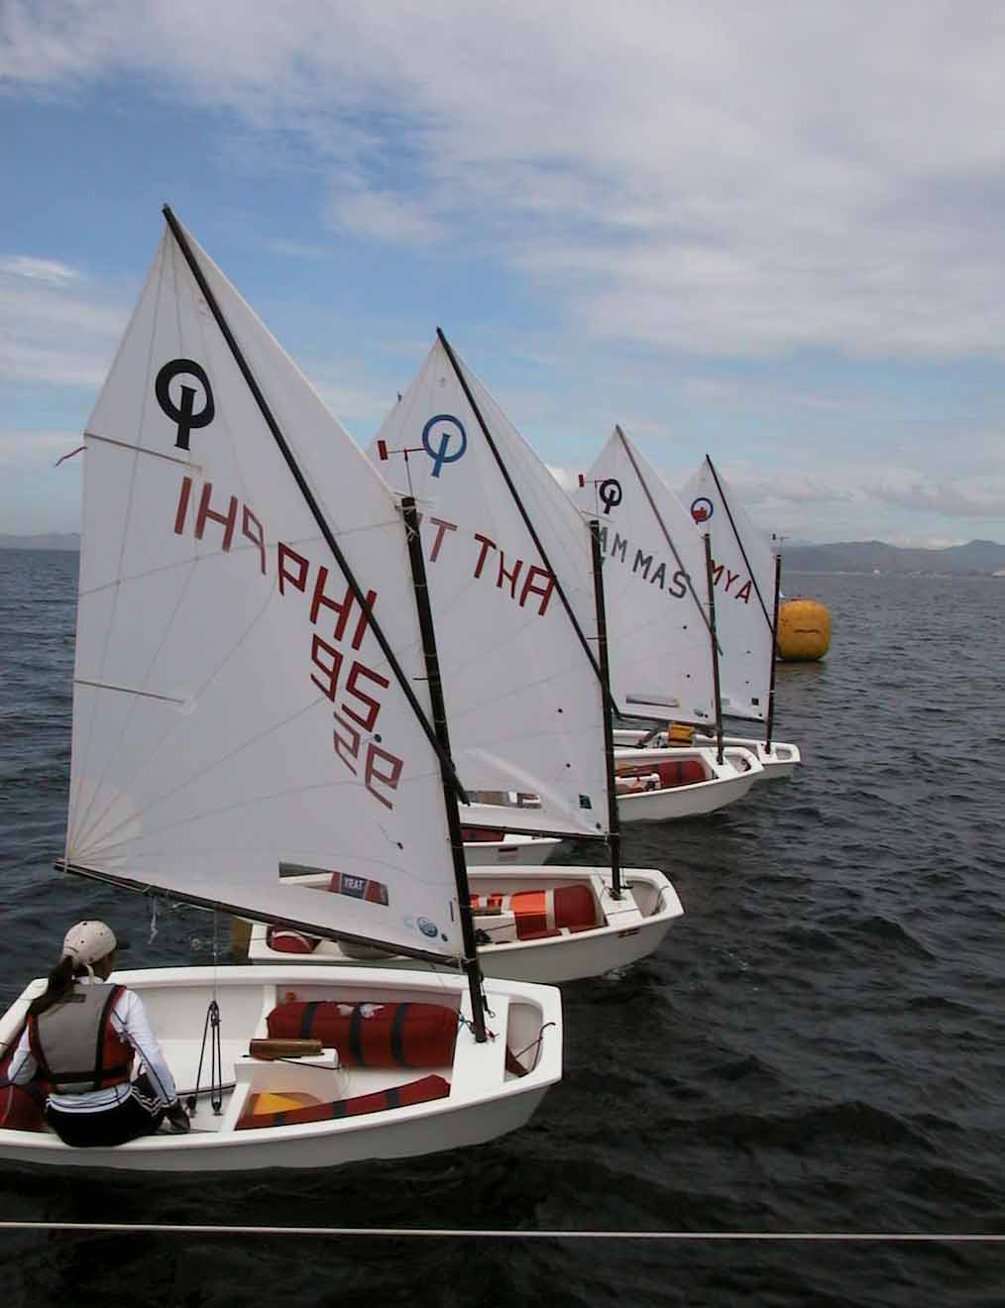
Kim Foley brings a wealth of sailing, coaching and teaching experience to the KYC Optimist Racing Team. She is a Canadian Yachting Association (CYA) certified Instructor Evaluator, which qualifies her to teach and evaluate not just student sailors, but sailing instructors at all levels. She has conducted various clinics for instructors in Ontario and Nova Scotia. Kim recently joined the Board of Directors of the CYA and was previously a Director and Vice-President, Training for Ontario Sailing.

Kim began her coaching career in 1998 at the Royal Hamilton Yacht Club (RHYC), where she coached novice, advanced and racing Optimist sailors over a four year period. During that period, she created an Optimist racing manual for her athletes. Since then, Kim has been sought out as a guest coach for various Optimist regattas and training sessions in Ontario and Manitoba. In addition to her Optimist coaching experience, Kim was Assistant Head Instructor at RHYC (2000 – 2001) and Head Instructor at KYC (2002 – 2003). She was named CYA Coach of the Year in 2002.

Contact Information
For information and registration forms please visit http://www.kingstonyachtclub.com or contact: Kingston Yacht Club - 1 Maitland Street, Kingston, Ontario, K7L 2V3 - Tel: (613) 548-3052, Fax: (613) 548-8876 or e-mail: office@kingstonyachtclub.com

