2009 Optimist Spring Training at ABYC

Three Days June 7, 21 and 28

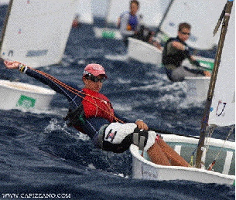
Registration now open

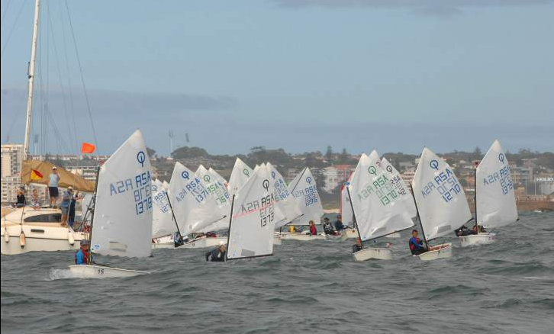

Why the Optimist?
- Designed for kids 7-15 years old
- 150,000 kids in 110 countries can’t be wrong
- Biggest and fastest growing dinghy class in the world
- The only dinghy recognized by the ISAF exclusively for under 16 years old
- Over 50% of the skippers at the last Olympics were Opti sailors
- Inexpensive and fun
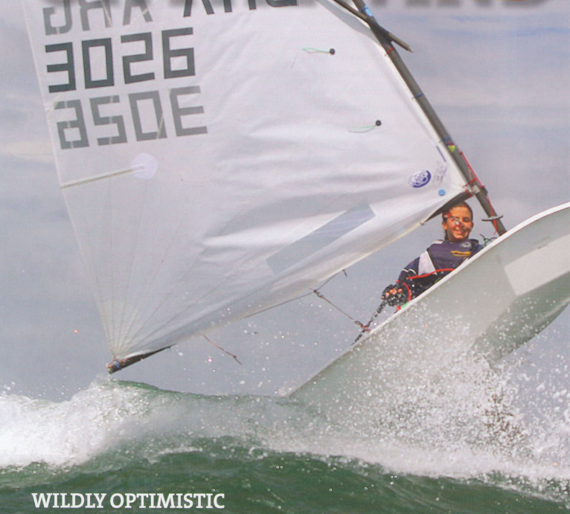

2009 Spring Opti Training
- Location: Ashbridges Bay Yacht Club
- For children 8-14 years old
- Curriculum focused on racing so some sailing experience beneficial
- Boat charters available or bring-your-own boat
- Sundays 11:00 am – 3:00 pm June 7, 21 and 28
- Appropriate attire required (wetsuit, rubber gloves and booties, spashguard/windbreaker, wool hat, PFD)
- Contact Finley McEwen, 416-694-3853 or finley-sophie.mcewen@sympatico.ca for more information
- Improve starts, boat handling, tactics, boatspeed and ultimately your results!

